**PROJECT Bank record generations 100 points**

**Objective** To write a program that performs data analysis from class objects created in lab #2.

**PROJECT DESCRIPTION**

Bank of IIT is in desperate need of analytics from its clients for its loan application process. Currently records show 600 clients exist and the bank is hoping to expand it’s clientele and it’s potential by offering premium loans to deserved grantees.

**Snapshots of Testcases:**

1. Initiation of BankRecordTest class

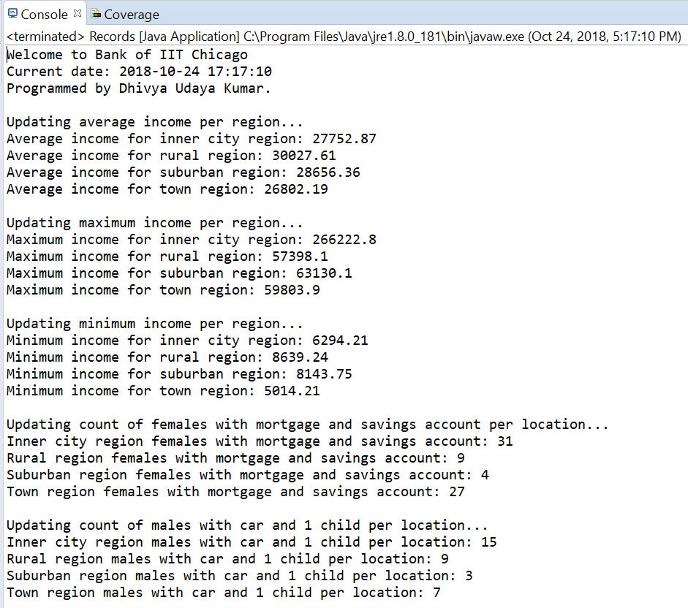

1. Screenshot of bankrecords.txt file:

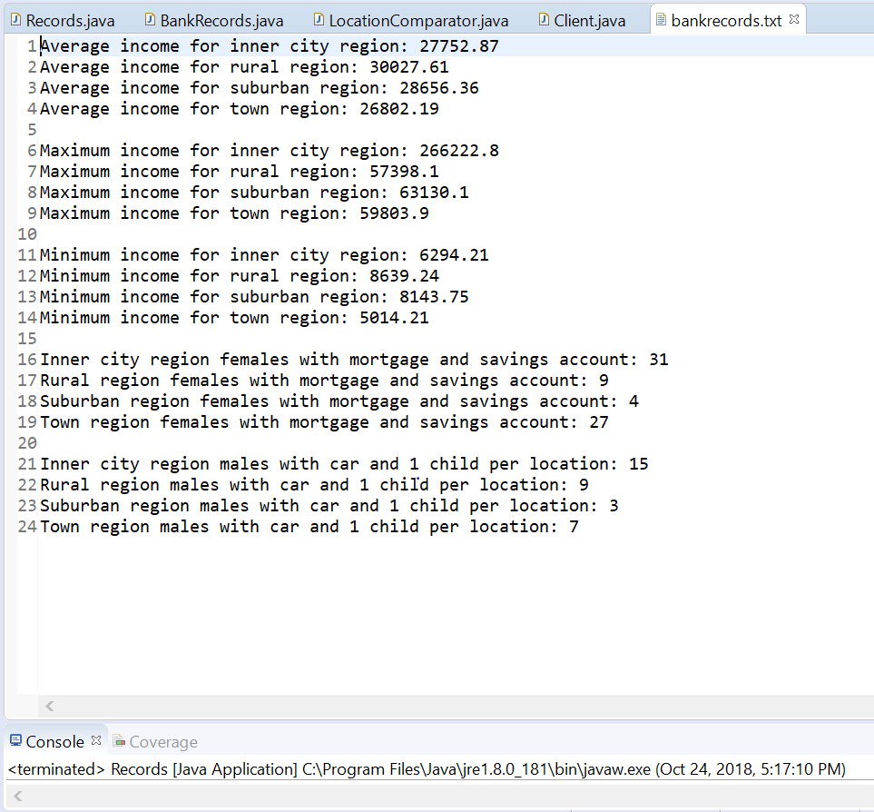

1. Handling file not found exception:

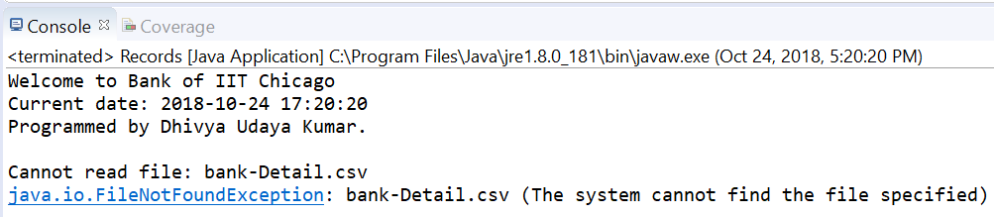

1. Handling empty file exception

